Lock-in Technique

23142, 10/12/19

# Abstract

An investigation into measuring the accuracy of the lock-in amplifier compared to an oscilloscope, by using optical filters to produce unwanted signal noise. The linearity of optical density to transmission intensity was then assessed using this technique and the limitations analysed.

# 1. Introduction

Standard amplifiers or detectors can only measure signals, at most, a magnitude greater with poor SNR; this proves to be an issue when applications require much greater accuracy. The lock-in amplifier is widely used in many areas of physics and technology, especially in astrophysics where signal information from astronomical objects, such as stars, is inevitably distorted. This method is even prevalent in improving vital optical experiments like the Michelson Interferometer or in Absorption Spectroscopy.

The lock-in technique is a powerful method to recover signals obscured by interference or disturbed by much larger noise. A lock-in amplifier is used with this method to home in on the desired signal and eliminate unwanted background noise. Fig. 1 illustrates this, even with system noise being thousands of times greater, the lock-in can provide accurate measurements, allowing signal detection towards the nanovolt regime and improving signal to noise ratio (SNR).

Reduced by ~ ${10}^{3}:1$

Lock-in Amplifier

Signal

Signal

Systemnoise

Background

Eliminated

**Fig. 1.** Visual to demonstrate the effects of the lock-in amplifier on input signals.

The objective of this experiment was to identify the measurement accuracy of a lock-in amplifier by comparing it to that of an oscilloscope. By using optical filters to produce a disturbed modulating signal from a laser. To then find the lowest transmission the lock-in could measure with increasing optical density. The transmission intensity was compared to theory to verify whether the optical density and transmission are linear. Finally, using the linearity association or otherwise, the optical density of an unknown filter was found. With Fig. 3 illustrating the extraction of signal surrounded by noise.

The lock-in amplifier implements the use of a reference signal to accurately measure the desired signal. Fig. 2 depicts the process in which the lock-in mixes the signals, with the distorted input signal being amplified and mixed with a phase-shifted reference. The demodulator recovers the information from the original desired wave and the low pass filter removes any extremity in the waveform.

Input amplifier

Demodulator

Phase Shifter

Signal Input

Reference Input

Low Pass Filter

Output

**Fig. 2.** A simplified block diagram depicting how the lock-in amplifier uses two input signals to output an improved SNR value.

The lock-in amplifier also allows the adjustment of a time constant, τ, which is also the integration time. The importance of the time constant is further analysed in the discussion. Concisely, Fig. 7 in the discussion demonstrates the effect of varying the time constant on the frequency bandwidth, such that a larger value improves the SNR.

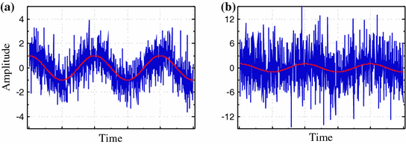

**Fig. 3.** Graphical representation of the lock-in amplifier identifying the same signal, shown in red, even when there is little noise (a) and significantly more noise (b) - as shown in blue. [1]

There are also limitations to the lock-in technique, such that the measuring accuracy is subject to the integration time, noise immunity and sampling frequency. Certain frequencies need to be avoided, such as electrical outlets at 50Hz as this would attribute additional unwanted noise.

# 2. Method

To investigate the lock-in technique, an apparatus like that in Fig. 4 was used. An optical bench was used, with a laser firing upon the sensor of a silicon photodiode (detector). A rotating “Chopper” was placed in front of the laser, such that the openings between the chopper blades were much greater than the width of the laser beam to ensure complete transmission during the choppers rotation. This optical chopper modulates the lasers direct voltage signal to a square wave signal of equivalent amplitude. An optical filter holder was used to place optical filters of known dimensionless optical densities. The chopper was connected to a frequency modulator that set the frequency of rotation with an analogue dial ranging from 1.0 to 100.0Hz. The detector was connected to an oscilloscope and the lock-in amplifier, producing a voltage signal from the converted optical input of the sensor. The frequency modulator was also connected to the oscilloscope and lock-in amplifier as shown in the schematic. Regarding individual connections, the output of the detector was the signal A input for the lock-in amplifier, and the frequency modulator was the reference signal. These outputs being input A and B in the oscilloscopes respectively. This allowed direct comparison of the lock-in amplifier to simply using an oscilloscope to measure the disturbed signal. A semi-transparent optical film was placed in front of the laser to reduce the incident intensity on the photodiode to not overload it.

Detector

Optical filters

Laser

Chopper

Oscilloscope

Lock-in Amplifier

Frequency modulator

**Fig. 4.** Schematic of the apparatus used, with each component placed on an optical bench and connecting lines used to represent BNC cables.

Commencing experimentation, the frequency modulator was set to (70.0 ± 1.0) Hz; a large uncertainty due to the analogue nature of the dial. The lock-in was set to polar output display and the oscilloscope set accordingly to display the square wave signal. The initial undisturbed (no filter) signal was measured on both devices, giving the value $I_{0}$ for each device. Using the $V_{Max}$ function on the oscilloscope along with cursors to identify the amplitude of the signal. The polar components of the signal were simply displayed on the lock-in; with the time constant, τ set to 300ms. Optical filters of varying optical density were then placed in the holder, with consecutive filters having their densities be summed. This allowed certain combinations of the given filters to produce measurements over 0 to 5.75. The voltage measurements started in the millivolt range and ended nearing the nanovolt range; hence measurements were kept in order of millivolts. The log of the measured voltages squared was taken, again kept in millivolts for sensible graphical comparability. This was then plotted against the optical density for both the oscilloscope and lock-in. The plot was compared to the theoretical concept applied by the optical transmission formula [2],

$I{=I}_{0}{10}^{-ρ}$; (1)

where, ρ is the optical density, $I_{0}$ as the unfiltered intensity and $I$ as the measured intensity. This demonstrates the degradation of signal clarity with increasing optical density due to the negative power. The relation, $I∝V^{2}$ was used to convert the transmission formula to voltage variables. This predicts linearity of -2 when simplified to,

$ρ=-2\log\left(\frac{V}{V_{0}}\right).$ (2)

The lock-in amplifier displays the polar components of the incoming mixed signal by separating the X and Y cartesian values and converting to [R, θ] polar values as shown in Fig. 5. The distorted signal and reference signal are mixed and then separated by the demodulator within the lock-in. The demodulator phase shifts the reference signal by $\frac{π}{2}$ radians, to sine and cosine components; such that the in-phase desired signal can be extracted. The polar conversion allows the amplitude, R, or equivalently the root mean square (RMS) voltage of the mixed signals to be obtained.

Demodulator

[R,θ]

X = Rcos(φ)

Y = Rsin(φ)

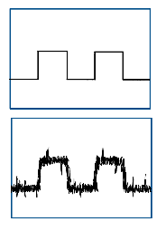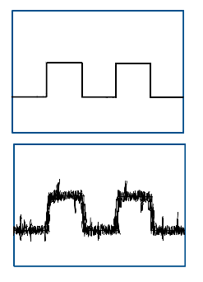

**Fig. 5.** Schematic depicting the function of the lock-in amplifier, converting the modulating signal to polar components.

To investigate the unknown filter, two approaches were implemented to find ρ. Firstly, the filter was placed in the apparatus and the voltage output recorded from both devices. Therefore, using the experimental plot (linear correlation fit), the voltage was identified and placed accordingly. Here, the optical density was the corresponding value at that point. The equivalent method was to use the theory, via equation (2), by substituting the measured voltage to acquire *ρ*. The standard deviation of the linear fit can also be used, this approach is explained in detail in the discussion.

# 3. Results

With the frequency of the modulator set at (70.0 ± 1.0) Hz, the chopper modulated the lasers beam to a square wave in direct contact with the detector – no filters placed. The amplitude of this wave was measured by the oscilloscope as (71.0 ± 0.5) mV and (65.0 ± 0.5) mV by the lock-in amplifier. This initial variation can be explained by the lock-in reducing external noise, this will be discussed further on. These values correspond to $V_{0}$ for each device respectively.

Both the oscilloscope and lock-in appear to remain constant at $V_{0}$ for optical densities up to 0.4 as shown by Fig. 6, this apparent *clipping* will be analysed in detail later. Both devices then identify the distorted signal up to about an optical density of 2.2 corresponding to an RMS voltage of ~ (1.0 ± 0.2) mV. Beyond this point, the oscilloscope struggled severely to measure the signal, with major fluctuations on the voltage as shown by the large error bars. With discrepancies oscillating much greater than the magnitude of the desired voltage, beyond this point no more data points were taken due to the signal becoming indistinguishable. This is considered the *noise floor* of the device, i.e. the level at which it can no longer lock-in to the signal. The lock-in amplifier continued to accurately measure the signal nearing the nanovolt regime. The minimum voltage accurately identified being 0.0005mV or about (500 ± 50) nV at an optical density of 5.3. Measurements beyond this point fluctuated more so, nonetheless having very small deviations in comparison to the oscilloscope at its noise floor. Approaching, and beyond the noise floor, the time constant was increased which resulted in much longer measurement times; though eventually provided a “stable” reading. Here, τ was increased from 300ms to 100s at peak.

Noise floor

**Fig. 6.** The identified voltages for increasing optical densities by the oscilloscope and lock-in amplifier showing a majority linear correlation.

Equation (2) predicts a linearity (gradient) of -2 to be obtained from the data. Where the linear regime for both devices was considered, with the initial clipping and the final fluctuations ignored. This gives a linearity coefficient of -2.01 ± 0.02 for the lock-in amplifier and -1.94 ± 0.03 for the oscilloscope. This gives a percentage error of 0.5% and 3% to the desired theoretical value respectively. The lock-in proves to be significantly accurate when compared to the theory, whilst also covering a much greater range of measurements.

With the unknown filter placed in the apparatus, the measured voltage, $V$ was (22.8 ± 0.1) mV and (21.6 ± 0.2) mV for the lock-in and oscilloscope respectively. By using Fig. 6 to reverse identify the optical density, the voltages corresponded to values of *ρ* as 0.9 for both devices. This optical density was largely above the noise floor for both devices, therefore, unsurprising for both to identify the same value. A more accurate comparison can be made using Equation (2) as previously mentioned, this gives a value of *ρ* as 0.91 ± 0.01 and 0.96 ± 0.02 for the lock-in and oscilloscope respectively; giving a percentage error of 1% and 7% to the confirmed value of *ρ* as 0.9.

**4. Discussion**

The primary aim of this investigation was to verify the measuring accuracy of the lock-in amplifier in identifying distorted signals. When comparing the lock-in to an oscilloscope, the lock-in managed to quickly and accurately obtain stable measurements of a signal thousands of magnitudes weaker. With the observed noise floor of the lock-in being 2400 times smaller. This was further emphasised with every measurement having little to no fluctuations in comparison to the large fluctuations approaching the noise floor of the oscilloscope.

With the lock-in maintaining a large signal to noise ratio throughout experimentation, having the minimum measurement at a remarkable 0.0005mV from an initial 65.0mV signal. A linearity was confirmed in the measurement of optical density to transmission. This was theorised by Equation (2) and the data from both devices appear to follow the relationship. With the lock-in having an error of 0.5% from the expected gradient of -2. This gradient is simply the conversion factor from optical transmission intensity to voltage as described in the derivation of Equation (2). When in fact, the linearity would be confirmed without the squared factor, hence an expected integer gradient which the results satisfy. Performing six times better than the oscilloscope having an error of 3% when confirming this linearity

When identifying the optical density of an unknown filter, the lock-in amplifier obtained the nearest value with an error about six times smaller than the oscilloscopes. The linearity in the obtained data also provided a quick identification method for the optical density in which the lock-in did successfully.

Errors and limitations

Even with the lock-in significantly out-performing the oscilloscope in these investigated areas, it did not pertain to perfect results. A key feature to identify is the *clipping* that both devices appear to encounter around the initial optical density measurements. This can be the result of the intensity being minimally reduced at such low optical densities. Though the lock-in amplifier is powerful in detecting very small changes to intensity even at the nanovolt scale, potentially an issue in the photodiode could be a cause. Another consideration in minimising errors was to avoid setting the frequency of the modulator at around 50Hz. This is the frequency range of UK outlets; therefore, the investigation would account for extra unwanted signal noise from the mains electricals. The use of optical filters with stated densities to a single decimal place results in a key factor for errors. Especially when filters were placed consecutively to be summed in densities, the minute errors in their stated values would be impactful over the sum of many filters. This was unavoidable at most, at best having to minimise the number of filters used when producing combinations.

Integration time, τ

The time constant, τ, is an intrinsic feature of the lock-in amplifier that allows further adjustment to the measurement of highly distorted signals. Ranging from 300ms to 100s with amplifier used here. This is seen as the integration time, the time window that allows the signal to stabilise and measured. A *filter bandwidth* corresponds to the time constant; it follows that the frequency at this filter bandwidth, $f_{BW}$ is inversely proportional to the time constant as,

$f_{BW}∝\frac{1}{τ}$. (3)

The filter bandwidth is the point at which signal power is attenuated by a half beyond the low pass regime. This results in a compromise when implementing the time constant for high distortion resolvability. This is graphically demonstrated in Fig. 7. Where setting a relatively small integration time allows for much faster measurements. With a large integration time having slow measurements and settling issues, where the signal struggles to stabilise over such a long period. Though, the disadvantage of a smaller time constant is that it allows more of the destabilised noise to be measured initially, resulting in a lower SNR. Also, extreme fluctuations nearing the low pass regime can leak into the measurement, again decreasing SNR. In this experiment, the smallest time constant was used throughout most measurements which appeared to be suitable until large optical densities. At this point, the time constant was increased to allow the signal to stabilise for longer and proved effective

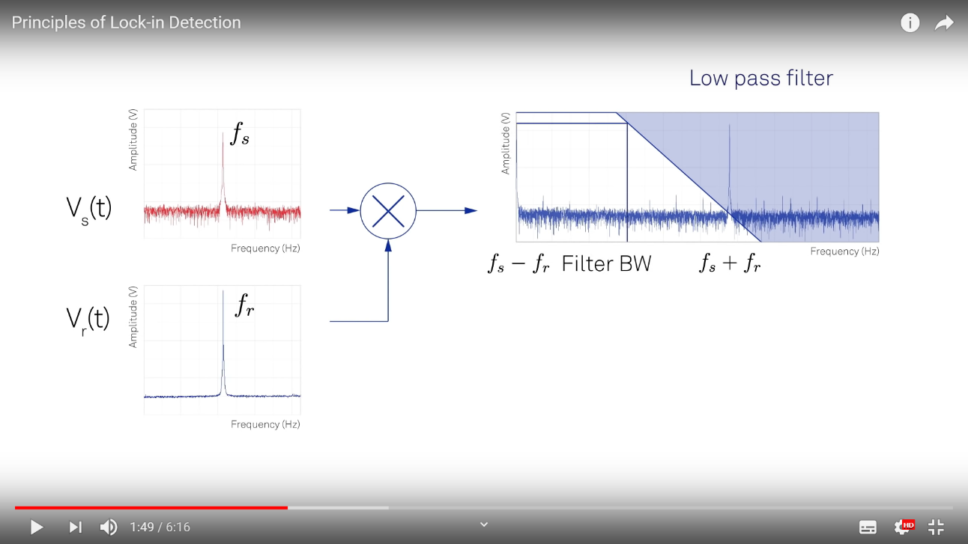

$→$ Decreasing τ

Increasing τ $←$

$$f_{BW}$$

Low Pass Filter

**Fig. 7.** Visual to demonstrate the effect of the low pass filter and the effect of changing the time constant, τ, on the frequency bandwidth, $f_{BW}$. [3]

Fast Fourier Transform

An interesting feature of the lock-in amplifier is the use of the Fast Fourier Transform within its demodulating process. The Fourier series states that any wave or signal can be expanded as an infinite sum of sine and cosine functions. The Fourier series formula is applied to voltage signals in the equation,

$V_{sig}≈ \sum^{n=∞}{A_{n}cos\left(nφ\right)+B_{n}sin\left(nφ\right)}$. (4)

The meaning of each term is insignificant in the analysis here as the emphasis is placed on the idea of reducing a complex function into linear sinusoidal variables. Demodulation applied to an expression of this form is equivalent to isolating the terms with frequencies within one filter bandwidth around the reference signal. In most cases, this reduces the infinite sum to just a sine and cosine term as the remaining components average to 0. This is readily obtained when the reference signal is phase shifted to a cosine wave by demodulating it with a sine wave equivalent to delaying by $\frac{π}{2}$ radians. The in-phase X component is the input signal that has come out of the low pass filter, this along with the phase shifted “quadrature” reference Y component. Together, these components are used to calculate the amplitude and phase angle via polar conversion. This is a powerful feature of the lock-in amplifier, allowing many signals to be analysed via Fourier Transforms.

Frequency and Intensity Dependence

Whether the lock-in technique was frequency or intensity dependant was an area investigated. A filter of optical density 1 was used and the frequency of the modulator varied from 10Hz to 300Hz. There was no clear method to verify intensity dependence with only a single laser provided, therefore using attenuators or optical sheets was the best approach. Unfortunately, the lock-in amplifier was unresponsive at this stage and measured no changes in transmission whilst the oscilloscope did†. Though there was no conclusive data for whether the technique is frequency dependant, research from papers [4] suggests there is a linear association. Regarding intensity, the paper gives evidence for the measured voltage being directly proportional to the power. This follows with the frequency dependence, where an increase in frequency reduces the measured voltage. The data suggest a linear correlation when the log of both variables is compared. The dependence for both variables minimally affects the experimentation for the lock-in technique, simply a consideration to maintain consistent values for both variables.

Lock-in to measure noise

An interesting feature of the lock-in amplifier is the ability to quantitatively identify the noise. As shown in Fig. 7, the low-pass filter removes noise dependant on the position of the filter bandwidth frequency. The noise can simply be measured using this as the standard deviation of the measured amplitude, R [5]. In this experiment, the noise was set using the optical densities, though another method of identifying unknown filters.

Phase Matching

Maintaining the same phase difference between reference and signal phase allows for more accurate measurements, considered *Phase-Sensitive Detection* [4]. Though this was not implemented in experimentation, the mathematical reasoning can be seen when considering the multiplication of sine waves executed by the lock-in amplifier. The filtered voltage measured includes a *Noise term* equivalent to a cosine term that can be minimised when phase-matched to the reference phase.

Future improvements

Briefly reviewed in the limitations section, many improvements could be implemented in this experiment. When using the oscilloscope to measure the signals, the distortion was readily observed on the screen. Therefore, connecting the lock-in amplifiers outputs to an oscilloscope to view a trace of the obtained signal would greatly help visualise the noise reduction in comparison. Another issue was the use of an analogue frequency modulator. The lock-in amplifier performs best when a highly accurate reference signal is used in demodulation. Therefore, having an analogue dial hindered the accuracy of setting a reference voltage, a digital device would be ideal. It would be worthwhile verifying the frequency and intensity dependence also, perhaps having lasers of different power outputs available and frequency modulator with a greater range of frequencies.

# 5. Conclusions

The method of the lock-in amplifier to measure greatly distorted signals is undeniably powerful. This technique allowed the measurement of signals in the nanovolt regime at a noise floor of (500 ± 50) nV, up to 2400 times better resolvability than that of an oscilloscope. With the obtained data following a linearity predicted by transmission laws. This experiment has many areas for improvement to further emphasise the resolving power of the lock-in amplifier. Nonetheless, an effective method that is unsurprisingly applied in many areas of physics like astronomical noise reduction and spectroscopy.

†*This was recognised and approved by lab supervisor Dr S Gordeev to be omitted.*

References

[1] B. Voigtländer. Lock-In Technique… Noise reduction. (2015).

[2] Chroma Technology. Percent Transmission and Optical density, (2018).

[3] Zurich Instruments. Principles of lock-in detection…Dual-phase demodulation. (2016).

[4] J. M Maxson. Using a Lock-In Amplifier. Frequency response and linearity. (2008).

[5] Stanford Research Systems. About Lock-In Amplifiers. Application Note #3: The Lock-in as a noise measurement device. (2019)